Department of Computer Science and Engineering
2025-2026
Odd Semester


DATA STRUCTURES AND ALGORITHMS-3
(25CS2103E)

HashPlag Detect

Tejasri 2520030139
Soumya Manasa 2520030304

COURSE INSTRUCTOR

Dr. J Sirisha Devi
Professor
Department of Computer Science and Engineering
HashPlage Detect : A Hashing-based Plagiarism Detection System
- Introduction:
Plagiarism is the act of copying another person's work, ideas, or written content and presenting it as one's own without proper acknowledgment. It is a common problem in educational institutions, research, and online content creation. Manually checking multiple documents for similarities can be time-consuming and inefficient, especially when the number of submissions is large.
HashPlag Detect is a plagiarism detection project that applies concepts from Data Structures and Algorithms (DSA) to identify similarities between text documents. The system uses hashing techniques to represent portions of text as hash values and compare them efficiently. Instead of comparing every character of every document repeatedly, hashing can help reduce the amount of work required to identify potentially matching content.
This project demonstrates how hashing, string processing, and efficient searching techniques can be applied to a practical problem. It also provides an opportunity to study algorithmic efficiency and the role of data structures in processing textual information.
- Problem Statement:
In educational institutions, students may submit assignments that contain copied sentences or paragraphs from other students or existing documents. Checking each submission manually becomes difficult when there are many documents to examine.
Traditional manual comparison requires considerable time and effort. A system is therefore needed to compare textual content efficiently and identify matching portions that may indicate plagiarism.
HashPlag Detect aims to address this problem by processing text, generating hash values for selected portions of documents, and comparing those values to identify potential similarities. The results can help users locate matching content for further examination.

- Objectives:
The main objectives of HashPlag Detect are:
- To develop a system for detecting potential plagiarism between text documents.
- To understand and implement hashing techniques.
- To apply appropriate data structures for storing and comparing text representations.
- To reduce unnecessary character-by-character comparisons.
- To analyze the time and space complexity of the implemented algorithms.
- To demonstrate the practical application of DSA concepts in text analysis.
- Algorithms used:
Hashing, String Processing, Hash Table, String Machine algorithms have been used in our project.
- Hashing: Converts a piece of text into a numerical value called a hash value. These values can be used to identify candidates matches between text segments.
- String Processing: System processes input documents and divides the text into suitable portions, depending on the implementation.
- Hash Table: Can store hash values and their associated text positions, allowing efficient lookup of previously processed segments.
- String Machine: System compares candidate matches to identify similar or repeated context.

- Working Procedure:
The general workflow is:
- The user provides two or more text documents for comparison.
- The system reads the documents and preprocesses their text.
- The text is divided into smaller segments, such as words or groups of words.
- Hash values are calculated for the selected segments.
- The generated hash values are stored in an appropriate data structure.
- The system compares the hash values of the documents to identify possible matches.
- Candidate matches are verified against the original text.
- The system displays the matching portions and a similarity result based on the implemented comparison method.

- Real-World Applications:
HashPlag Detect can be applied in several areas:

- Educational institutions: Comparing student assignments and reports.
- Research: Identifying repeated passages in research documents.
- Content publishing: Checking articles for duplicated text.
- Online platforms: Detecting repeated textual submissions.
- Document management: Finding duplicate or highly similar text records.

- Conclusion:
HashPlag Detect demonstrates how data structures and algorithms can be applied to a real-world text-comparison problem. By using hashing and string-processing techniques, the system can identify potential matches between documents while reducing unnecessary comparisons.
The project provides practical experience in algorithm design, data storage, searching, and complexity analysis. It also highlights the importance of verifying hash matches against the original text to improve reliability. Overall, HashPlag Detect illustrates the usefulness of DSA concepts in developing efficient text-analysis applications.

ALGORITHM / PSEUDO CODE
  - Step-by-Step Representation of the Algorithm

Step 1: Start the System:
The system begins execution and initializes the variables, data structures, and functions required for document comparison. It prepares the storage required for hash values and matching text segments.
Step 2: Accept Input Documents:
The user provides two text documents for comparison. The first document is treated as the reference document, while the second document is treated as the document to be checked.
The system verifies that both documents are available and contain readable text. If either document is empty or cannot be read, an appropriate error message is displayed.
Step 3: Preprocess the Text
The system preprocesses the contents of both documents to make comparison consistent. Depending on the implementation, preprocessing may include:
- Converting uppercase letters into lowercase letters.
- Removing unnecessary leading and trailing spaces.
- Normalizing repeated whitespace.
- Removing selected punctuation marks, if required.
For example:
Original text: Data Structures and Algorithms
Preprocessed text: data structures and algorithms
The same preprocessing rules must be applied to both documents.
Step 4: Divide Text into Segments
The preprocessed text is divided into smaller segments. These segments may consist of individual words or groups of consecutive words called k-grams.
For example, if the text is:
data structures and algorithms
and the selected segment size is two words, the segments are:
- data structures
- structures and
- and algorithms
Using groups of words helps the system identify similarities in context rather than relying only on individual words.

Step 5: Generate Hash Values
The system calculates a hash value for each text segment using a selected hashing function.
A hash function maps a text segment to a numerical value. The resulting value is used as a compact representation of the segment for comparison.
Text Segement | Illustrative hash value
data structures | H1
structures | H2
algorithms | H3

The symbols H1, H2, and H3 represent hash values; they are not actual calculated values. The numerical values depend on the hash function used.
Step 6: Store the Hash Values
The hash values generated from the reference document are stored in a suitable data structure, such as a hash table or dictionary. The associated text segments and their positions may also be stored.
This arrangement allows the system to search for corresponding hash values without scanning the entire reference document for every segment.
If multiple segments have the same hash value, the system must handle them appropriately rather than assuming that every equal hash represents identical text.
Step 7: Compare the Documents
The algorithm generates hash values for the segments in the second document and checks whether those values exist in the reference document's stored hash data.
- If a hash value is not found, the segment is not identified as a hash-based candidate match.
- If a hash value is found, the corresponding text segment is selected for further verification.
This process identifies candidate matching segments efficiently.
Step 8: Verify Candidate Matches
Hash collisions can occur when different text segments produce the same hash value. Therefore, the system verifies candidate matches by comparing the original text segments.
If the text segments are identical after preprocessing, the segment is recorded as a confirmed textual match. Otherwise, the collision is rejected as a false match.
Step 9: Calculate the Similarity Result
After processing all segments, the system summarizes the number of matching segments and the total number of segments examined.
If the implementation uses a segment-based similarity calculation, it may calculate a percentage using:
Similarity Percentage = (Number of Matching Segments / Total Segments in the Checked Document) × 100
For example, if 8 out of 20 segments match, the result is:
Similarity Percentage = (8 / 20) × 100 = 40%
This is an illustrative segment-match percentage, not necessarily a complete measure of plagiarism. The formula should match the method actually implemented in the project.
Step 10: Display the Results
The system displays the comparison results, which may include:
- The names of the compared documents.
- The number of segments examined.
- The number of matching segments.
- The identified matching text, where supported.
- The calculated similarity percentage, if implemented.
The result helps the user identify text that may require further examination.
Step 11: Stop the System
After displaying the results, the system releases any resources it no longer needs and terminates execution.
Pseudocode
Algorithm: HashPlag Detect
Input: Reference document D1 and checked document D2.
Output: Matching text segments and a similarity result.
BEGIN

READ document D1
READ document D2

IF D1 or D2 is empty OR cannot be read THEN
DISPLAY "Error: Invalid or empty document"
STOP
END IF

T1 ← PREPROCESS(D1)
T2 ← PREPROCESS(D2)

S1 ← DIVIDE_INTO_SEGMENTS(T1)
S2 ← DIVIDE_INTO_SEGMENTS(T2)

CREATE an empty hash table H
CREATE an empty list MATCHES

FOR each segment X in S1 DO
HV ← HASH(X)
STORE HV and the required segment information in H
END FOR

FOR each segment Y in S2 DO
HY ← HASH(Y)

IF HY exists in H THEN

FOR each candidate segment X associated with HY DO

IF X is identical to Y THEN
ADD Y to MATCHES
RECORD its position if required
END IF

END FOR

END IF
END FOR

TOTAL ← NUMBER OF SEGMENTS IN S2
COUNT ← NUMBER OF MATCHING SEGMENTS

IF TOTAL > 0 THEN
SIMILARITY ← (COUNT / TOTAL) × 100
ELSE
SIMILARITY ← 0
END IF

DISPLAY MATCHES
DISPLAY COUNT
DISPLAY SIMILARITY

END

CODE
import com.sun.net.httpserver.HttpExchange;
import com.sun.net.httpserver.HttpServer;
import java.awt.Desktop;
import java.io.IOException;
import java.io.OutputStream;
import java.net.InetSocketAddress;
import java.net.URI;
import java.net.URLDecoder;
import java.nio.charset.StandardCharsets;
import java.nio.file.*;
import java.util.*;
import java.util.regex.*;
import java.util.zip.*;

public class HashPlagServer {
private static final long BASE = 256;
private static final long MOD = 1_000_000_007L;
static class Doc {
final String name, text;
Doc(String name, String text) { this.name = name; this.text = text; }
}
static class Result {
final Doc a, b;
final boolean[] markA, markB;
final int hits, collisions, verified;
final Set<String> linePairs;
final double simA, simB, overall;
Result(Doc a, Doc b, boolean[] mA, boolean[] mB, int hits, int coll, int ver, Set<String> linePairs) {
this.a = a; this.b = b; markA = mA; markB = mB;
this.hits = hits; this.collisions = coll; this.verified = ver;
this.linePairs = linePairs;
simA = percent(mA); simB = percent(mB); overall = (simA + simB) / 2.0;
}
static double percent(boolean[] m) {
if (m.length == 0) return 0;
int c = 0;
for (boolean x : m) if (x) c++;
return 100.0 * c / m.length;
}
}
static String preprocess(String raw) {
// Keep line breaks so the UI can report the line number of matching text.
String s = raw.replace("\r\n", "\n").replace('\r', '\n').toLowerCase();
String[] lines = s.split("\\n", -1);
StringBuilder out = new StringBuilder();
for (int i = 0; i < lines.length; i++) {
String line = lines[i].replaceAll("[^a-z0-9\\s]", " ");
line = line.replaceAll("[ \t\f]+", " ").trim();
if (i > 0) out.append('\n');
out.append(line);
}
return out.toString();
}
static long initialHash(String s, int w) {
long h = 0;
for (int i = 0; i < w; i++) h = (h * BASE + s.charAt(i)) % MOD;
return h;
}
static long highPower(int w) {
long p = 1;
for (int i = 1; i < w; i++) p = (p * BASE) % MOD;
return p;
}
static long roll(long h, char out, char in, long pow) {
h = (h - out * pow % MOD + MOD) % MOD;
return (h * BASE + in) % MOD;
}
static int lineNumberAt(String text, int pos) {
int line = 1;
for (int i = 0; i < pos && i < text.length(); i++)
if (text.charAt(i) == '\n') line++;
return line;
}
static String matchedTextOnLine(String text, boolean[] mark, int targetLine) {
int line = 1;
StringBuilder out = new StringBuilder();
int i = 0;
while (i < text.length()) {
if (text.charAt(i) == '\n') {
if (line == targetLine) break;
line++;
i++;
continue;
}
if (line == targetLine && mark[i]) {
int start = i;
while (i < text.length() && text.charAt(i) != '\n' && mark[i]) i++;
String part = text.substring(start, i).trim();
if (!part.isEmpty()) {
if (out.length() > 0) out.append(" ... ");
out.append(part);
}
} else {
i++;
}
}
return out.toString();
}
static Result compare(Doc a, Doc b, int w) {
boolean[] markA = new boolean[a.text.length()];
boolean[] markB = new boolean[b.text.length()];
int hits = 0, coll = 0, ver = 0;
Set<String> linePairs = new LinkedHashSet<>();
if (a.text.length() < w || b.text.length() < w)
return new Result(a, b, markA, markB, 0, 0, 0, new LinkedHashSet<>());
long pow = highPower(w);
Map<Long, List<Integer>> table = new HashMap<>(); // hash -> positions in A
long h = initialHash(a.text, w);
for (int i = 0; ; i++) {
table.computeIfAbsent(h, k -> new ArrayList<>()).add(i);
if (i + w >= a.text.length()) break;
h = roll(h, a.text.charAt(i), a.text.charAt(i + w), pow);
}
h = initialHash(b.text, w);
for (int j = 0; ; j++) {
List<Integer> positions = table.get(h);
if (positions != null) {
for (int i : positions) {
hits++;
if (a.text.regionMatches(i, b.text, j, w)) { // verify real text
ver++;
int lineA = lineNumberAt(a.text, i);
int lineB = lineNumberAt(b.text, j);
linePairs.add(lineA + ":" + lineB);
for (int k = 0; k < w; k++) { markA[i + k] = true; markB[j + k] = true; }
} else coll++; // hash collision
}
}
if (j + w >= b.text.length()) break;
h = roll(h, b.text.charAt(j), b.text.charAt(j + w), pow);
}
return new Result(a, b, markA, markB, hits, coll, ver, linePairs);
}
static String verdict(double p) {
if (p >= 70) return "HIGH plagiarism";
if (p >= 30) return "MODERATE similarity";
if (p > 0) return "LOW similarity";
return "No similarity";
}
static String esc(String s) {
return s.replace("&", "&amp;").replace("<", "&lt;").replace(">", "&gt;");
}
static String highlight(String text, boolean[] mark) {
StringBuilder sb = new StringBuilder();
boolean open = false;
for (int i = 0; i < text.length(); i++) {
if (mark[i] && !open) { sb.append("<mark>"); open = true; }
if (!mark[i] && open) { sb.append("</mark>"); open = false; }
sb.append(esc(String.valueOf(text.charAt(i))));
}
if (open) sb.append("</mark>");
return sb.toString();
}
static class LineMatch {
final int line;
final String text;
LineMatch(int line, String text) { this.line = line; this.text = text; }
}

static List<LineMatch> lineMatches(String text, boolean[] mark) {
List<LineMatch> out = new ArrayList<>();
int lineNo = 1;
int i = 0;
while (i < mark.length) {
if (text.charAt(i) == '\n') {
lineNo++;
i++;
continue;
}
if (!mark[i]) {
i++;
continue;
}
int start = i;
int currentLine = lineNo;
while (i < mark.length && mark[i] && text.charAt(i) != '\n') i++;
String snippet = text.substring(start, i).trim();
if (!snippet.isEmpty()) out.add(new LineMatch(currentLine, snippet));
}
return out;
}
static String q(String s) { // JSON string literal
StringBuilder sb = new StringBuilder("\"");
for (char c : s.toCharArray()) {
switch (c) {
case '"': sb.append("\\\""); break;
case '\\': sb.append("\\\\"); break;
case '\n': sb.append("\\n"); break;
case '\r': sb.append("\\r"); break;
case '\t': sb.append("\\t"); break;
default:
if (c < 0x20) sb.append(String.format("\\u%04x", (int) c)); else sb.append(c);
}
}
return sb.append('"').toString();
}

static String toJson(List<Doc> docs, List<Result> results, int w, List<String> warnings) {
StringBuilder j = new StringBuilder("{\"window\":" + w + ",\"warnings\":[");
for (int i = 0; i < warnings.size(); i++) { if (i > 0) j.append(','); j.append(q(warnings.get(i))); }
j.append("],\"documents\":[");
for (int i = 0; i < docs.size(); i++) {
if (i > 0) j.append(',');
j.append(q(docs.get(i).name));
}
j.append("],\"results\":[");
for (int i = 0; i < results.size(); i++) {
Result r = results.get(i);
if (i > 0) j.append(',');
j.append("{\"a\":").append(q(r.a.name)).append(",\"b\":").append(q(r.b.name))
.append(String.format(Locale.US, ",\"simA\":%.2f,\"simB\":%.2f,\"overall\":%.2f", r.simA, r.simB, r.overall))
.append(",\"verdict\":").append(q(verdict(r.overall)))
.append(",\"hits\":").append(r.hits).append(",\"verified\":").append(r.verified)
.append(",\"collisions\":").append(r.collisions)
.append(",\"matches\":[");
int pairIndex = 0;
for (String pair : r.linePairs) {
String[] parts = pair.split(":");
int lineA = Integer.parseInt(parts[0]);
int lineB = Integer.parseInt(parts[1]);
String textA = matchedTextOnLine(r.a.text, r.markA, lineA);
String textB = matchedTextOnLine(r.b.text, r.markB, lineB);
if (textA.isEmpty() || textB.isEmpty()) continue;
if (pairIndex++ > 0) j.append(',');
j.append("{\"aLine\":").append(lineA)
.append(",\"aText\":").append(q(textA))
.append(",\"bLine\":").append(lineB)
.append(",\"bText\":").append(q(textB)).append("}");
}
j.append("]}");
}
return j.append("]}").toString();
}
static final Set<String> SUPPORTED = new LinkedHashSet<>(Arrays.asList(
"txt","md","csv","tsv","log","json","xml","java","py","c","cpp","js","css","tex",
"html","htm","rtf","docx","dotx","pptx","xlsx","odt","odp","ods","pdf"));

static String extractText(String fileName, byte[] data) throws Exception {
String ext = fileName.contains(".") ? fileName.substring(fileName.lastIndexOf('.') + 1).toLowerCase() : "txt";
switch (ext) {
case "docx": case "dotx":
return zipRegex(data, n -> n.equals("word/document.xml") || n.matches("word/(header|footer|footnotes|endnotes)\\d*\\.xml"),
"<w:t(?:\\s[^>]*)?>([^<]*)</w:t>|</w:p>|<w:tab/>");
case "pptx":
return zipRegex(data, n -> n.matches("ppt/slides/slide\\d+\\.xml"),
"<a:t>([^<]*)</a:t>|</a:p>");
case "xlsx":
return zipRegex(data, n -> n.equals("xl/sharedStrings.xml") || n.matches("xl/worksheets/sheet\\d+\\.xml"),
"<t(?:\\s[^>]*)?>([^<]*)</t>|</si>|</row>");
case "odt": case "odp": case "ods":
return zipOpenDocument(data);
case "pdf":
return pdfText(data);
case "rtf":
return rtfText(new String(data, StandardCharsets.ISO_8859_1));
case "html": case "htm":
return htmlText(new String(data, StandardCharsets.UTF_8));
case "doc": case "ppt": case "xls":
throw new IOException("old binary ." + ext + " format is not supported - save it as ." + ext + "x (or PDF) and upload again");
default:
if (!SUPPORTED.contains(ext)) throw new IOException("unsupported file type ." + ext);
return new String(data, StandardCharsets.UTF_8);
}
}

/** Reads matching entries of a zip (docx/pptx/xlsx) and pulls text with the given regex. */
static String zipRegex(byte[] data, java.util.function.Predicate<String> pick, String regex) throws IOException {
TreeMap<String, byte[]> parts = new TreeMap<>(HashPlagServer::naturalCompare);
try (ZipInputStream z = new ZipInputStream(new java.io.ByteArrayInputStream(data))) {
ZipEntry e;
while ((e = z.getNextEntry()) != null)
if (pick.test(e.getName())) parts.put(e.getName(), z.readAllBytes());
} catch (ZipException ze) {
throw new IOException("file is corrupted or not a valid Office document");
}
if (parts.isEmpty()) throw new IOException("no readable content found in file");
Pattern pat = Pattern.compile(regex);
StringBuilder out = new StringBuilder();
for (byte[] part : parts.values()) {
Matcher m = pat.matcher(new String(part, StandardCharsets.UTF_8));
while (m.find()) out.append(m.group(1) != null ? unescape(m.group(1)) : (m.group().equals("<w:tab/>") ? " " : "\n"));
out.append('\n');
}
return out.toString();
}

static String zipOpenDocument(byte[] data) throws IOException {
try (ZipInputStream z = new ZipInputStream(new java.io.ByteArrayInputStream(data))) {
ZipEntry e;
while ((e = z.getNextEntry()) != null) {
if (e.getName().equals("content.xml")) {
String x = new String(z.readAllBytes(), StandardCharsets.UTF_8);
x = x.replaceAll("</text:(p|h)>|<text:line-break/>|<text:tab/>", "\n");
return unescape(x.replaceAll("<[^>]+>", ""));
}
}
}
throw new IOException("no readable content found in file");
}

static String htmlText(String h) {
h = h.replaceAll("(?is)<(script|style)[^>]*>.*?</\\1>", " ").replaceAll("(?s)<!--.*?-->", " ");
h = h.replaceAll("(?i)</?(p|div|br|li|tr|h[1-6]|table|section|article)[^>]*>", "\n");
return unescape(h.replaceAll("<[^>]+>", " "));
}

static String rtfText(String r) {
Set<String> skipWords = new HashSet<>(Arrays.asList("fonttbl","colortbl","stylesheet","info","pict","header","footer","generator","listtable","listoverridetable","rsidtbl"));
StringBuilder out = new StringBuilder();
int depth = 0, skipDepth = -1, n = r.length();
for (int i = 0; i < n; i++) {
char c = r.charAt(i);
if (c == '{') depth++;
else if (c == '}') { if (skipDepth == depth) skipDepth = -1; depth--; }
else if (c == '\\' && i + 1 < n) {
char d = r.charAt(i + 1);
if (d == '\\' || d == '{' || d == '}') { if (skipDepth < 0) out.append(d); i++; }
else if (d == '\'' && i + 3 < n) {
try { int v = Integer.parseInt(r.substring(i + 2, i + 4), 16);
if (skipDepth < 0) out.append(new String(new byte[]{(byte) v}, "windows-1252")); } catch (Exception ignored) {}
i += 3;
} else if (d == '*') { if (skipDepth < 0) skipDepth = depth; i++; }
else if (Character.isLetter(d)) {
int j = i + 1;
while (j < n && Character.isLetter(r.charAt(j))) j++;
String word = r.substring(i + 1, j);
int k = j;
if (k < n && (r.charAt(k) == '-' || Character.isDigit(r.charAt(k)))) { k++; while (k < n && Character.isDigit(r.charAt(k))) k++; }
String param = r.substring(j, k);
if (k < n && r.charAt(k) == ' ') k++;
if (skipWords.contains(word) && skipDepth < 0) skipDepth = depth;
else if (skipDepth < 0) {
if (word.equals("par") || word.equals("line") || word.equals("sect")) out.append('\n');
else if (word.equals("tab")) out.append(' ');
else if (word.equals("u") && !param.isEmpty()) {
int cp = Integer.parseInt(param); if (cp < 0) cp += 65536;
out.append((char) cp);
if (k < n) k++; // skip fallback char
}
}
i = k - 1;
} else i++;
} else if (skipDepth < 0 && c != '\r' && c != '\n') out.append(c);
}
return out.toString();
}

/** PDF text via Apache PDFBox (jar in the lib/ folder), loaded by reflection. */
static String pdfText(byte[] data) throws Exception {
Class<?> docC, strC;
try {
docC = Class.forName("org.apache.pdfbox.pdmodel.PDDocument");
strC = Class.forName("org.apache.pdfbox.text.PDFTextStripper");
} catch (ClassNotFoundException e) {
throw new IOException("PDF support needs the PDFBox jar in the 'lib' folder (see README)");
}
Object doc = null;
try {
doc = docC.getMethod("load", byte[].class).invoke(null, (Object) data);
Object stripper = strC.getDeclaredConstructor().newInstance();
return (String) strC.getMethod("getText", docC).invoke(stripper, doc);
} catch (java.lang.reflect.InvocationTargetException e) {
Throwable t = e.getCause() != null ? e.getCause() : e;
throw new IOException("cannot read PDF (" + t.getClass().getSimpleName() + (t.getMessage() != null ? ": " + t.getMessage() : "") + ")");
} finally {
if (doc != null) try { docC.getMethod("close").invoke(doc); } catch (Exception ignored) {}
}
}

static String unescape(String s) {
s = s.replace("&lt;", "<").replace("&gt;", ">").replace("&quot;", "\"").replace("&apos;", "'").replace("&nbsp;", " ");
Matcher m = Pattern.compile("&#(x?)([0-9a-fA-F]+);").matcher(s);
StringBuffer sb = new StringBuffer();
while (m.find()) {
try {
int cp = Integer.parseInt(m.group(2), m.group(1).isEmpty() ? 10 : 16);
m.appendReplacement(sb, Matcher.quoteReplacement(new String(Character.toChars(cp))));
} catch (Exception e) { m.appendReplacement(sb, " "); }
}
m.appendTail(sb);
return sb.toString().replace("&amp;", "&");
}

static int naturalCompare(String a, String b) { // slide2 before slide10
Matcher x = Pattern.compile("\\d+").matcher(a), y = Pattern.compile("\\d+").matcher(b);
if (x.find() && y.find() && a.replaceAll("\\d+", "").equals(b.replaceAll("\\d+", "")))
return Long.compare(Long.parseLong(x.group()), Long.parseLong(y.group()));
return a.compareTo(b);
}
static void send(HttpExchange ex, int code, String type, byte[] body) throws IOException {
ex.getResponseHeaders().set("Content-Type", type);
ex.sendResponseHeaders(code, body.length);
try (OutputStream os = ex.getResponseBody()) { os.write(body); }
}

/** Body format: window=30&name=a.docx&data=<base64>&name=b.pdf&data=<base64>... */
static void handleCompare(HttpExchange ex) throws IOException {
if (!ex.getRequestMethod().equalsIgnoreCase("POST")) {
send(ex, 405, "text/plain", "Use POST".getBytes()); return;
}
try {
String body = new String(ex.getRequestBody().readAllBytes(), StandardCharsets.UTF_8);
int w = 30;
List<String> names = new ArrayList<>(), datas = new ArrayList<>();
for (String pair : body.split("&")) {
int eq = pair.indexOf('=');
if (eq < 0) continue;
String k = pair.substring(0, eq);
String v = URLDecoder.decode(pair.substring(eq + 1), StandardCharsets.UTF_8);
if (k.equals("window")) w = Math.max(5, Math.min(200, Integer.parseInt(v.trim())));
else if (k.equals("name")) names.add(v);
else if (k.equals("data")) datas.add(v);
}
List<String> warnings = new ArrayList<>();
List<Doc> docs = new ArrayList<>();
for (int i = 0; i < names.size() && i < datas.size(); i++) {
try {
String text = preprocess(extractText(names.get(i), Base64.getDecoder().decode(datas.get(i))));
if (text.isEmpty()) warnings.add(names.get(i) + ": no readable text found (scanned/image-only file?) - skipped");
else docs.add(new Doc(names.get(i), text));
} catch (Exception e) {
warnings.add(names.get(i) + ": " + e.getMessage() + " - skipped");
}
}
if (docs.size() < 2) {
StringBuilder msg = new StringBuilder("Need at least 2 readable documents.");
for (String wn : warnings) msg.append(' ').append(wn).append('.');
send(ex, 400, "application/json", ("{\"error\":" + q(msg.toString()) + "}").getBytes(StandardCharsets.UTF_8)); return;
}
List<Result> results = new ArrayList<>();
for (int i = 0; i < docs.size(); i++)
for (int k = i + 1; k < docs.size(); k++)
results.add(compare(docs.get(i), docs.get(k), w));
send(ex, 200, "application/json; charset=utf-8", toJson(docs, results, w, warnings).getBytes(StandardCharsets.UTF_8));
} catch (Exception e) {
send(ex, 500, "application/json", ("{\"error\":" + q(String.valueOf(e.getMessage())) + "}").getBytes(StandardCharsets.UTF_8));
}
}
static Path webDir;
static void handleStatic(HttpExchange ex) throws IOException {
String path = ex.getRequestURI().getPath();
if (path.equals("/")) path = "/index.html";
Path f = webDir.resolve(path.substring(1)).normalize();
if (!f.startsWith(webDir) || !Files.isRegularFile(f)) {
send(ex, 404, "text/plain", "Not found".getBytes()); return;
}
String type = path.endsWith(".html") ? "text/html; charset=utf-8"
: path.endsWith(".css") ? "text/css; charset=utf-8"
: path.endsWith(".js") ? "application/javascript; charset=utf-8"
: "application/octet-stream";
send(ex, 200, type, Files.readAllBytes(f));
}
public static void main(String[] args) throws Exception {
for (String c : new String[]{"web", "../web", "HashPlagWeb/web"}) {
Path p = Paths.get(c).toAbsolutePath().normalize();
if (Files.isRegularFile(p.resolve("index.html"))) { webDir = p; break; }
}
if (webDir == null) {
System.out.println("Cannot find the 'web' folder (index.html). Open the HashPlagWeb folder in VS Code and run again.");
return;
}
int port = 8080;
HttpServer server = null;
for (; port < 8090 && server == null; port++) {
try { server = HttpServer.create(new InetSocketAddress(port), 0); } catch (IOException busy) { /* try next */ }
}
port--;
if (server == null) { System.out.println("No free port between 8080-8089."); return; }
server.createContext("/api/compare", HashPlagServer::handleCompare);
server.createContext("/", HashPlagServer::handleStatic);
server.start();

String url = "http://localhost:" + port;
System.out.println("HashPlag Detect running at " + url + " (press Ctrl+C / Stop to quit)");
System.out.println("Serving frontend from: " + webDir);
try {
if (Desktop.isDesktopSupported()) Desktop.getDesktop().browse(new URI(url));
} catch (Exception ignored) { }
}
}

RESULTS

Screenshots
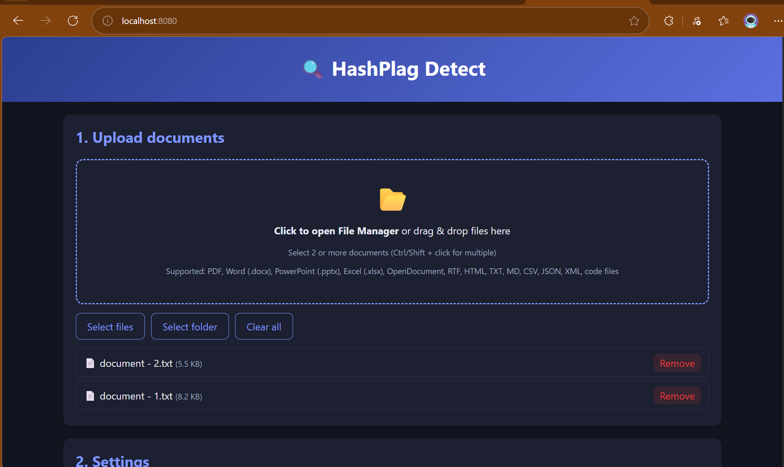
In the above we are going to upload the documents and we can also see which documents are supported by the website

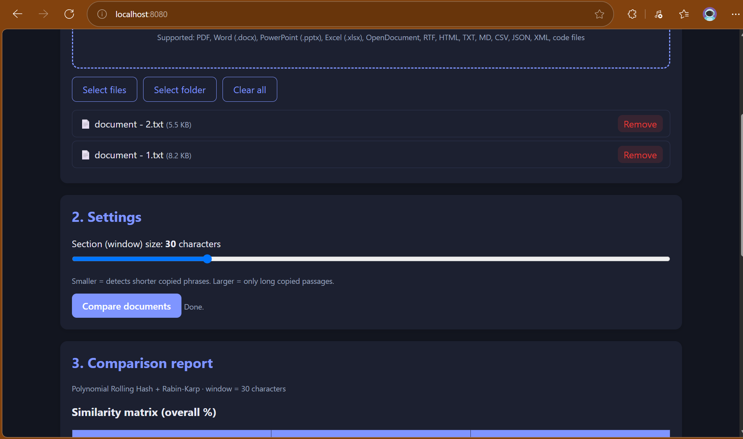
After uploading the files, we have to set the character window size according to the length of the text and the level of similarity we want to detect.
In your project, “window” simply means a small portion of the text that the system checks at one time.
For example, if you set:
Window size = 30 characters
the system takes 30 characters at a time and checks whether those 30 characters are similar to another document.
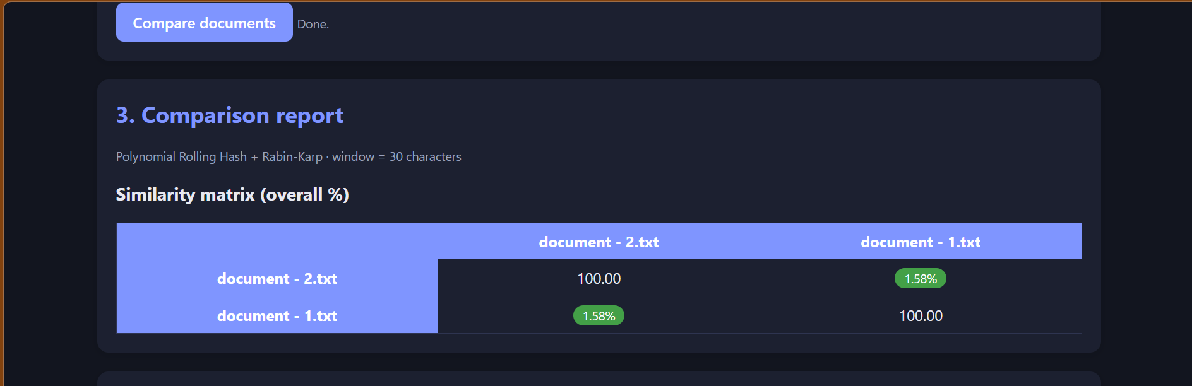
After uploading the files, the window size is set to 30 characters. Here, 30 characters means that the system checks 30 characters of text at a time. The window moves through the document and compares each section with the other document to find matching content. After the comparison, the system displays the similarity percentage based on the matching text.
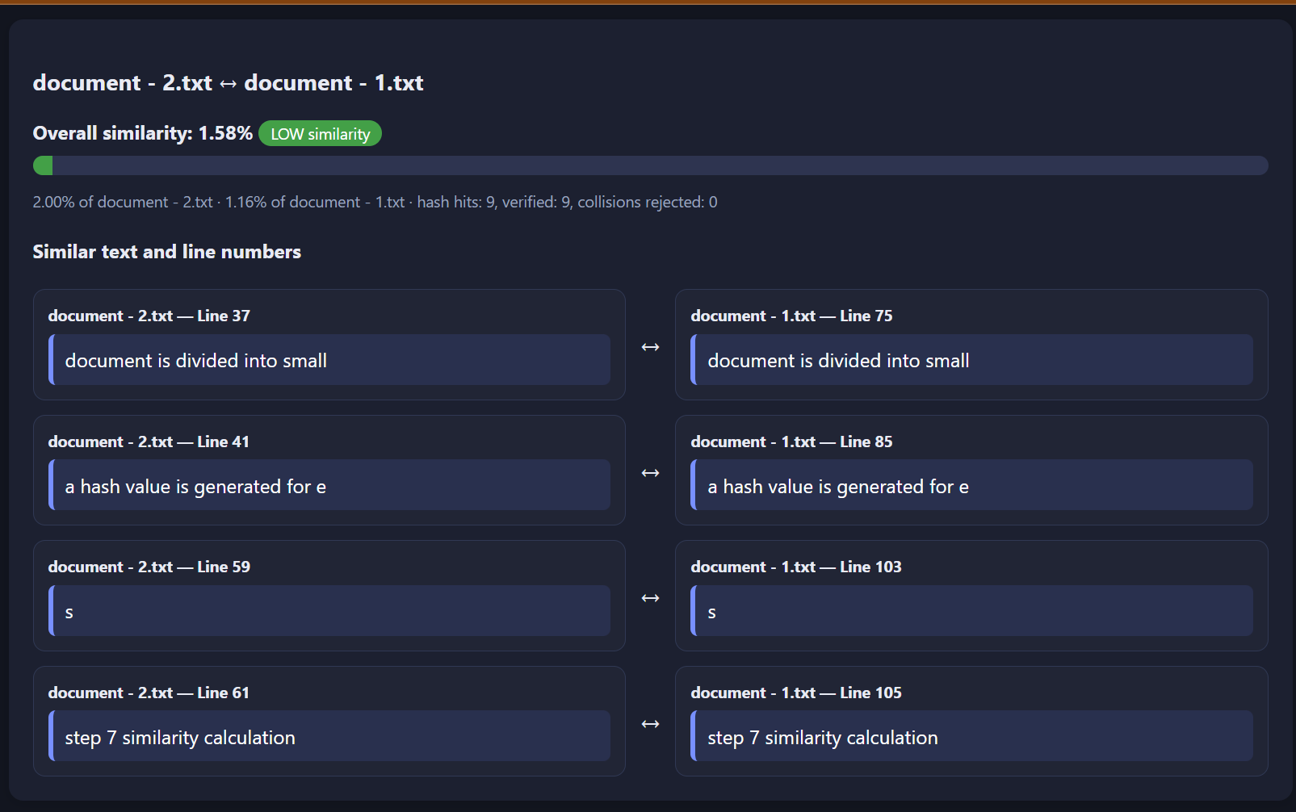
After comparing the two uploaded documents using a 30-character window size, the system calculates the overall similarity and identifies the matching portions of text. In this example, the overall similarity is 1.58%, which is classified as low similarity. The system detected 9 hash hits, and all 9 were verified as actual text matches, with no hash collisions rejected. Instead of displaying the complete documents, the system displays only the similar text along with the corresponding line numbers, making it easier to identify and verify the matching content.

